**CODE FACTORY**

**Go To App For many paid**

**and free Courses**

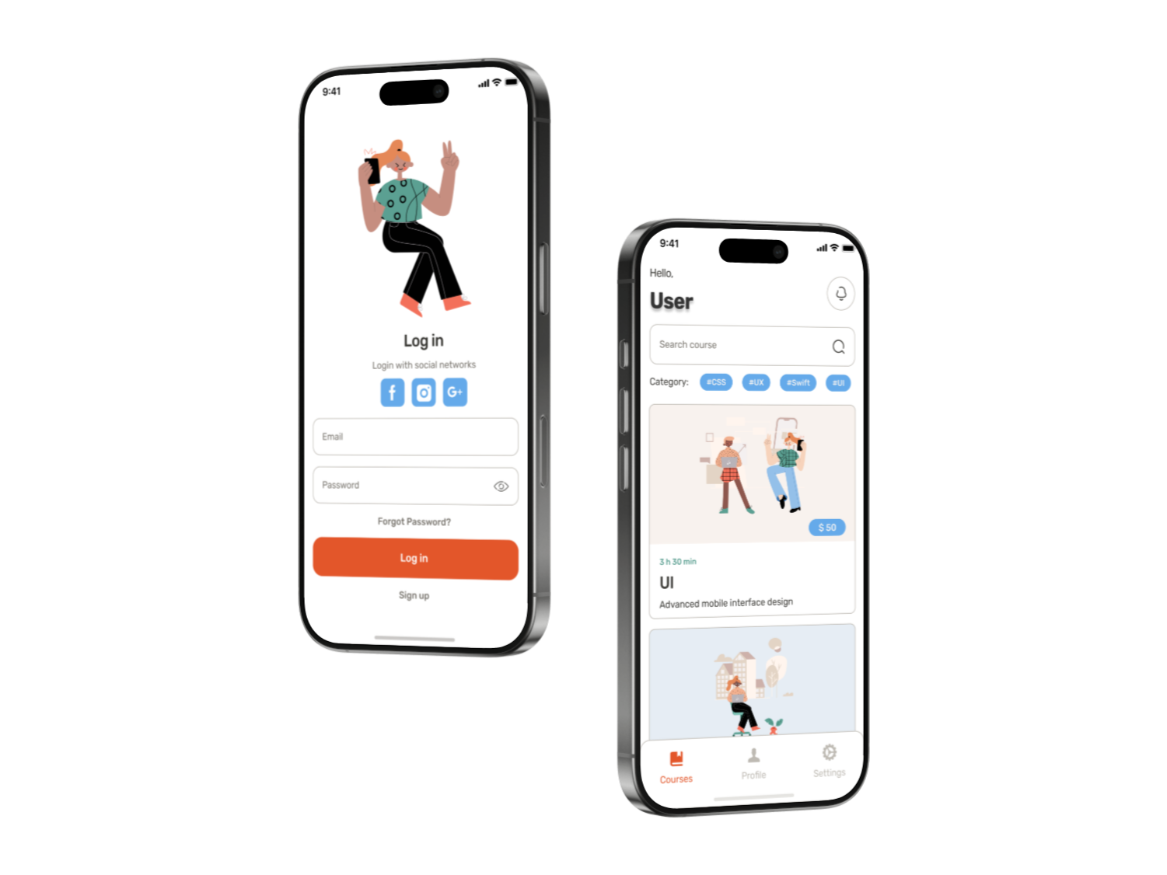

Login Page and course Search Details

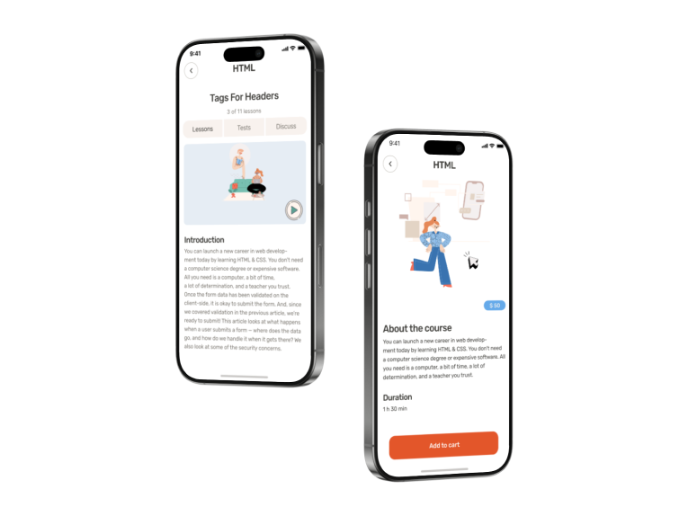

Saved course viewing and course details

Aim:

To enable users to accurately and efficiently submit course records within the app, ensuring all relevant information such as aim, procedure, profile details, course information, payment, and settings are recorded in a structured and organized manner.

Procedure:

1. **Navigate to the Record Submission Section:**

Access the record submission feature through the main dashboard or profile section.

1. **Enter Basic Course Information:**

Fill out fields for the course aim, procedure, and other essential details.

1. **Complete Profile Information:**

Provide user details (e.g., name, contact information) necessary for course tracking.

1. **Input Course Details:**

Add specifics about the course content, including syllabus overview, objectives, and instructor information.

1. **Add Payment Details:**

Enter required payment information, select a payment method, and review the cost breakdown.

1. **Set Preferences in Settings:**

Adjust any additional settings, such as notification preferences or data-sharing permissions.

**RESULT:**

Hence an prototype of an learning platform’s design is created!